­­

EVENT MANAGEMENT SYSTEM

B-tech Computer science and engineering (II semester)

**Submitted by: -**

VAIBHAV SAXENA(41)

KRUTI JAYASAI(39)

Narapureddy Kushal Kumar Reddy(40)

**Submitted to: -**

Mrs. Manu Bali

Table of Content

1. INTRODUCTION
2. ACKNOWLEDGMENT
3. PROJECT OUTLINE
4. CONCEPTS AND TAGS USED
5. TEAMWORK
6. REFERENCES
7. CONCLUSION

# **Acknowledgment**

We would like to express my

special thanks of gratitude

to my teacher Mrs. Manu Bali,

who gave me the golden

opportunity to do this project

of building website of

“EVENT MANAGEMENT SYSTEM”.

Who also guided us in completing this project. We came to know about many new things and we are really thankful to them.

Hope you will like the efforts we have putted in this project.

Thank You.

# **INTRODUCTION**

*Event management is the application of*[*project management*](https://en.wikipedia.org/wiki/Project_management)*to the creation and development of large-scale events such as*[*festivals*](https://en.wikipedia.org/wiki/Festival)*, conferences, ceremonies, weddings, formal parties, concerts, or*[*conventions*](https://en.wikipedia.org/wiki/Convention_(meeting))*. It involves studying the brand, identifying its*[*target audience*](https://en.wikipedia.org/wiki/Target_audience)*, devising the event concept, and coordinating the technical aspects before actually launching the event.*

*The events industry now includes events of all sizes from the*[*Olympics*](https://en.wikipedia.org/wiki/Olympics)*down to business breakfast meetings. Many industries,*[*charitable organizations*](https://en.wikipedia.org/wiki/Charitable_organization)*, and interest groups hold events in order to market their label, build business relationships, raise money, or celebrate achievement.*

*The process of planning and coordinating the event is usually referred to as event planning and which can include budgeting, scheduling, site selection, acquiring necessary*[*permits*](https://en.wikipedia.org/wiki/License)*, coordinating transportation and parking, arranging for speakers or entertainers, arranging decor, event security,*[*catering*](https://en.wikipedia.org/wiki/Catering)*, coordinating with third party vendors, and emergency plans. Each event is different in its nature so process of planning & execution of each event differs on basis of type of event.*

*The event manager is the person who plans and executes the event, taking responsibility for the creative, technical, and logistical elements. This includes overall event design, brand building, marketing and communication strategy,*[*audio-visual*](https://en.wikipedia.org/wiki/Audio-visual)*production, script writing, logistics, budgeting, negotiation, and client service.*

# **PROJECT OUTLINE**

**Project Name:** *EVENT MANAGEMENT SYSTEM*

**Developed At:**  *Lovely Professional University*

**Languages Used:** *HTML, CSS*

**Software Used:** *Atom*

**Browser Used:** Google Chrome

**Developed By:**

Vaibhav Saxena,

Kruti Jayasai,

Narapureddy Kushal Kumar Reddy

**Guidance By:**  Mrs. Manu Bali

**Description:**

This project is actually a template of a website which is not capable of working on internet. Its just a template for Event Management System and it will work fine if added with backend languages.

Website is consist of various html pages, which are linked to each other.

List of files used in the project:-

* **rkm.html**
* **login.html**
* **signup.html**
* **Loginsl.css**
* **Signups.css**
* **Style.css**

**CONCEPTS AND TAGS USED**

1. <script> tag having src attribute.
2. <div> tag.
3. <h1><h2> tags for Heading.
4. <img> tag for images.
5. Class and href tag for link.
6. <form> for login and signup.
7. <input> tags for input field for the users.
8. <button> tag for buttons.

**TEAM MEMBERS:**

1. Vaibhav saxena
   1. Idea of project.
   2. Structuring html.and final touchup.

1. Kruti Jayasai:
   1. Creating CSS file, to make our webpages beautiful and final analysis.
2. Narapureddy Kushal Kumar Reddy
   1. Creating Synopsis,and final touch up to website.

WE three worked as a team and supported each other in building this website each person has its own credit for the website. Everyone has his own importance in making pages of html and css . We worked equally putting equal amounts of efforts, because united we stand divided we fall.

HOME PAGE:

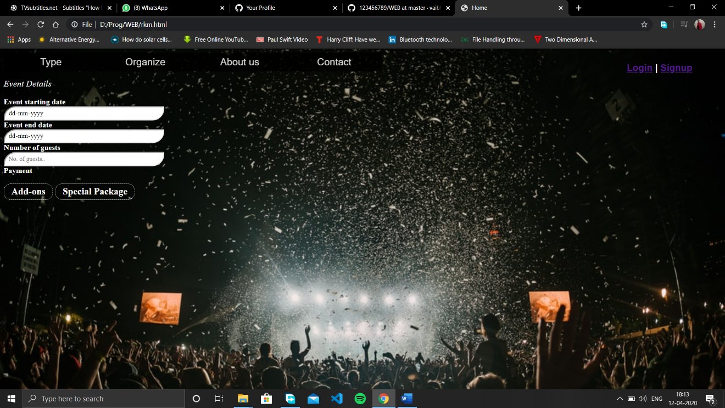

Login:

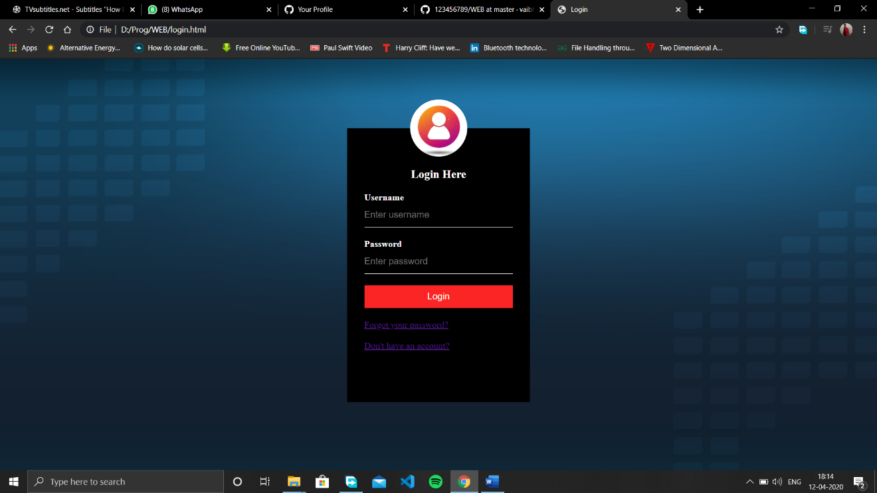

Sign-up:

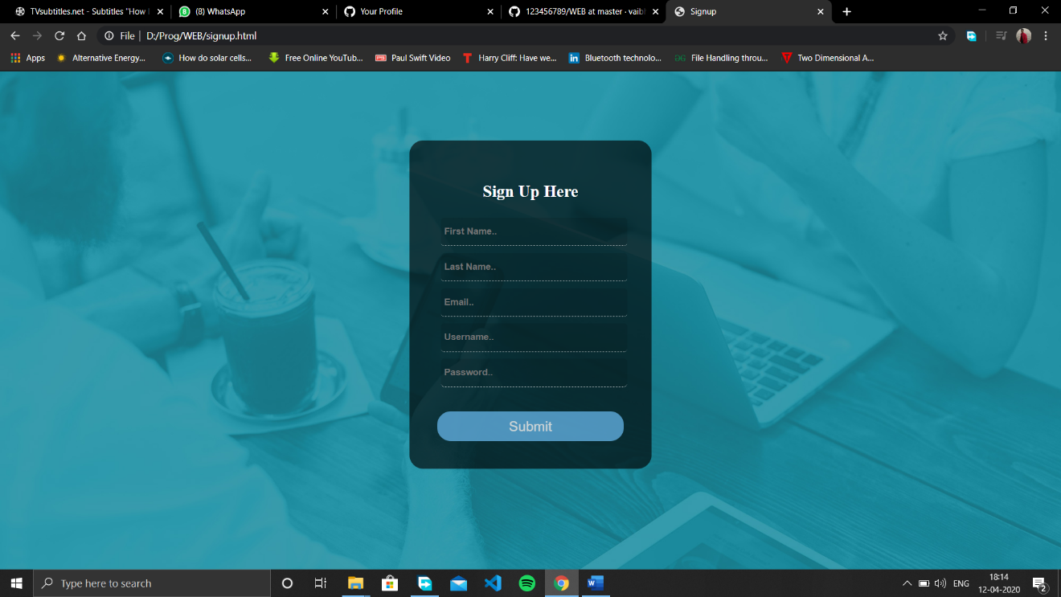

# **REFERENCES**

* W3schools.org
* Geeksforgeeks.com
* Tutorialspoint.com
* Images from Google.com
* Wikipedia.